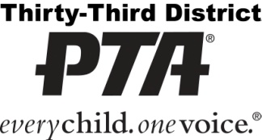

Thirty-Third District PTA
Program Directory Awards 2020-2021
INSTRUCTIONS FOR UNITS (your school’s PTA)

The purpose of a program directory is to give PTA, school, and school district information to your school's PTA board and/or to the entire school community. Program Directories can be in any form: booklet, pamphlet, trifold, folder, digital, etc. With the COVID -19 pandemic situation, best practice is for your program directory be in digital form. Your PTA program directory should be ready for distribution shortly after the start of the school year. Even though your publication contains school information, it is a PTA program directory, not a school program directory, and PTA information should appear first.
Thirty-Third District PTA Awards:
  - Program directories must be distributed by December 1, 2020 to qualify for awards.
  - Program directories distributed by November 1, 2020 will earn the Early Bird Award.
  - The submission form lists items that should be included in your program directory.
Each item is worth 1, 2, or 3 points; the 3 point items being the most important.
  - Your point total will determine your award level.
    - Gold: 70 + points
    - Silver: 55-69 points
    - Bronze: 40-54 points

  - Turn in one copy of the program directory and submission form with checklist by the council deadline: December 4, 2020.

Questions? Contact your council chairman: Nancy Shafer
Email/phone: busterthecatshafer@gmail.com

NOTE TO COUNCIL: Council must submit all unit directories and submission forms to Thirty-Third District PTA on or before January 13, 2021. Please email all submissions to pta33rdleadership@gmail.com.
Council needs to review each unit directory and fill out the ‘council use’ column on the submission form. Council will award the unit points for each item. For example, for a three point item: if the item is not in the program directory, it will receive zero points. If it is in the program directory correctly, it will receive three (3) points. If it is in the program directory but not accurate (for example, not in the right location, or not complete, or not accurate) it will receive one (1) or two (2) points. Thirty-Third District PTA will also grade each directory and make the final decision.
Questions? Contact Thirty-Third District PTA Director of Leadership Michelle VanLerberghe pta33rdleadership@gmail.com

Cheat Sheet for Important Items to Include in Your Directory
All in one place so you don’t have to search.

- PTA name, logo, and tagline:
Instructions and guidelines for the logo can be found at https://capta.org/pta-leaders/run-your-pta/building-membership/visual-identity-and-pta-logos/

Clover Elementary School
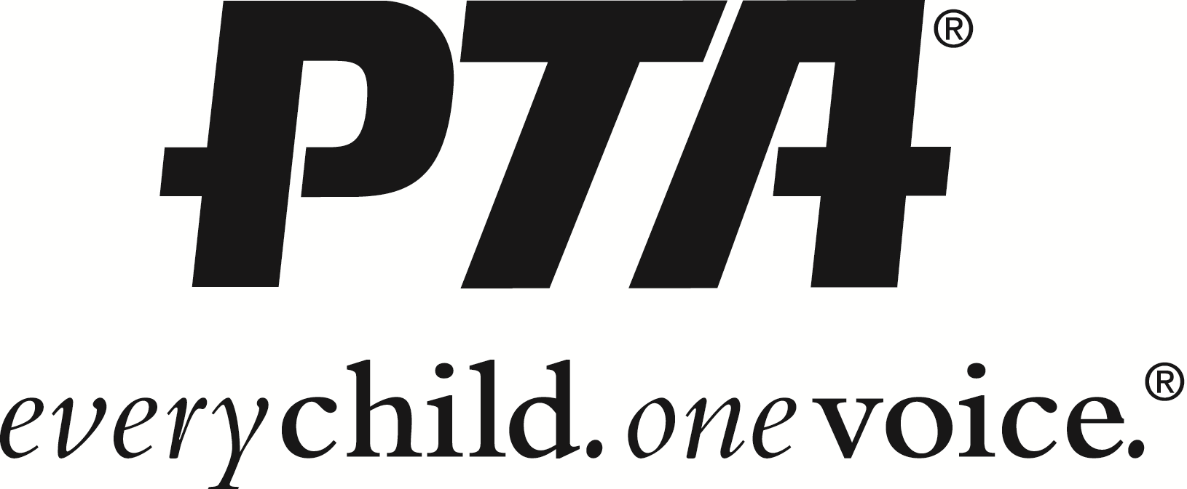

Briar Middle School
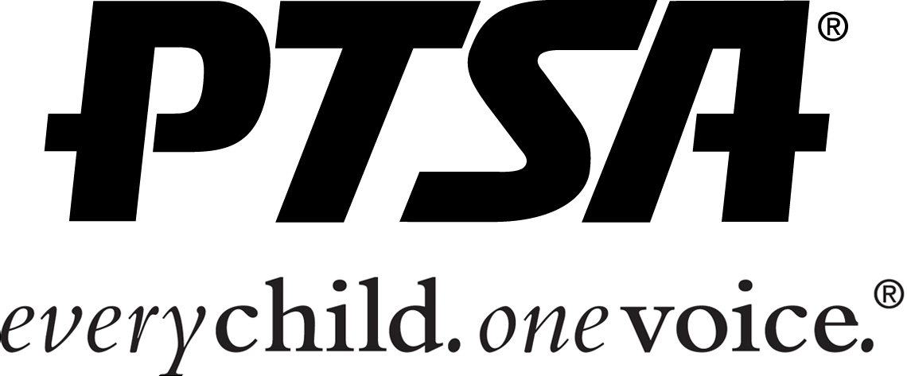
- California State PTA Mission Statement:
The mission of the California State PTA is to positively impact the lives of all children and families.

- California State PTA Purpose:
- To promote the welfare of children and youth in home, school, places of worship, and throughout the community;
- To raise the standards of home life;
- To advocate for laws that further the education, physical and mental health, welfare, and safety of children and youth;
- To promote the collaboration and engagement of families and educators in the education of children and youth;
- To engage the public in united efforts to secure the physical, mental, emotional, spiritual, and social well-being of all children and youth; and
- To advocate for fiscal responsibility regarding public tax dollars in public education funding.
- Disclaimers:
Disclaimer to use if the program/directory is distributed to PTA board members only:
- This program/directory has been completed for the sole use and convenience of the (school name here) PTA/PTSA officers, chairmen, and advisory personnel. All names and phone numbers are for PTA use only. PLEASE GUARD CAREFULLY AGAINST UNAUTHORIZED USE BY OTHERS.

Disclaimer to use if the program/directory is distributed school district wide:
- This program/directory has been completed for the sole use and convenience of the (school name here) parents and staff. All names and phone numbers are for PTA use only. PLEASE GUARD CAREFULLY AGAINST UNAUTHORIZED USE BY OTHERS.

- District, State, and National PTA contact information:

THIRTY-THIRD DISTRICT PTA

Cindy Ellenberg, President
5629 Pearce Avenue
Lakewood, CA 90712
Mail to: PO Box 1235
Lakewood, CA 90714
562-804-4519
Fax: 562-804-5460
pta33rdpresident@gmail.com
www.33rdpta.org
CALIFORNIA STATE PTA

Celia Jaffe, President
2327 L Street
Sacramento, CA 95816
916-440-1985
Fax: 916-440-1986
info@capta.org
www.capta.org

NATIONAL PTA

Leslie Boggs, President
1250 N. Pitt Street
Alexandria, VA 22314
800-307-4PTA
Fax: 703-836-0942
info@pta.org
www.pta.org

Thirty-Third District PTA
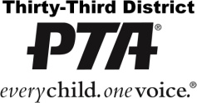
Program Directory Awards Unit Submission Form

Unit Name: |  | Council:
Program Directory Chairperson:
Phone: | Email:
Unit President:
Phone: | Email:

Unit Directory Chair: Check off each item included in your directory in the column only.
Council Use | points |  |  |  | Council Use | points
 | EB |  | Early Bird: Enter date distributed:
 | 3 |  | Distributed to members by 12/01/20 |  | IN DIRECTORY, ANY LOCATION
 |  |  |  |  |  | 3 |  | PTA & School Event Calendar
COVER |  |  |  |  |  | 3 |  | Meeting dates, times, and locations
 | 3 |  | Name of PTA |  |  | 3 |  | List of unit officers and chairmen,
 | 3 |  | PTA logo, name and tagline (see Unit Instructions) |  |  |  |  | including their PTA positions and at least
 | 3 |  | School year ‘2020 – 2021’ |  |  |  |  | one type of contact information
 |  |  |  |  |  |  |  | (email, phone, address)
COVER, INSIDE FRONT COVER, or FIRST PAGE |  |  |  |  |  | 2 |  | Council PTA president’s name/ contact info
 | 3 |  | PTA founding year (find on front cover of bylaws) |  |  | 2 |  | District PTA president’s name/
 | 3 |  | PTA website address (if no website, write ‘N/A’) |  |  |  |  | contact info
 | 3 |  | Purposes of the PTA (see Unit Instructions) |  |  | 2 |  | California State PTA president’s name/
 | 3 |  | California State PTA Mission Statement |  |  |  |  | contact info
 |  |  | (see Unit Instructions) |  |  | 2 |  | National PTA president’s name/contact info
 | 3 |  | Council PTA Name |  |  | 3 |  | Teacher and administrator list
 | 3 |  | Thirty-Third District PTA |  |  | 2 |  | Bell schedule
 | 3 |  | California State PTA |  |  | 2 |  | School map
 | 3 |  | Disclaimer (see Unit Instructions) |  |  | 2 |  | Superintendent’s name
 | 3 |  | School street address |  |  | 2 |  | School district office address and phone number
 | 3 |  | School phone number |  |  | 2 |  | School district board members’ names/
 | 3 |  | School website address |  |  |  |  | contact info
 |  |  |  |  |  | 2 |  | City Council members’ names/contact info or link

 | 1 |  | President’s theme / logo |  | 1 |  | Table of contents |  | 1 |  | School emergency/disaster procedure
 | 1 |  | Unit mission statement |  | 1 |  | Libraries (city/county) |  | 1 |  | Electric company emergency number
 | 1 |  | PTA membership (how to join) |  | 1 |  | Parks |  | 1 |  | Gas company emergency number
 | 1 |  | Program descriptions |  | 1 |  | Suicide prevention hotline |  | 1 |  | Water company emergency number
 | 1 |  | Message from PTA president |  | 1 |  | Poison control number |  | 1 |  | Hospital/emergency rooms
 | 1 |  | Message from principal |  | 1 |  | Graffiti removal number |  | 1 |  | U.S. Senators’ contact info or link
 | 1 |  | School rules |  | 1 |  | Animal control number |  | 1 |  | U.S. Representative contact info or link
 | 1 |  | Student contact information |  | 1 |  | Police/Sheriff # (non-emergency) |  | 1 |  | CA Senator contact info or link
 | 1 |  | School after hrs emergency # |  | 1 |  | Fire Dept. # (non-emergency) |  | 1 |  | CA Assemblymember contact info or link

